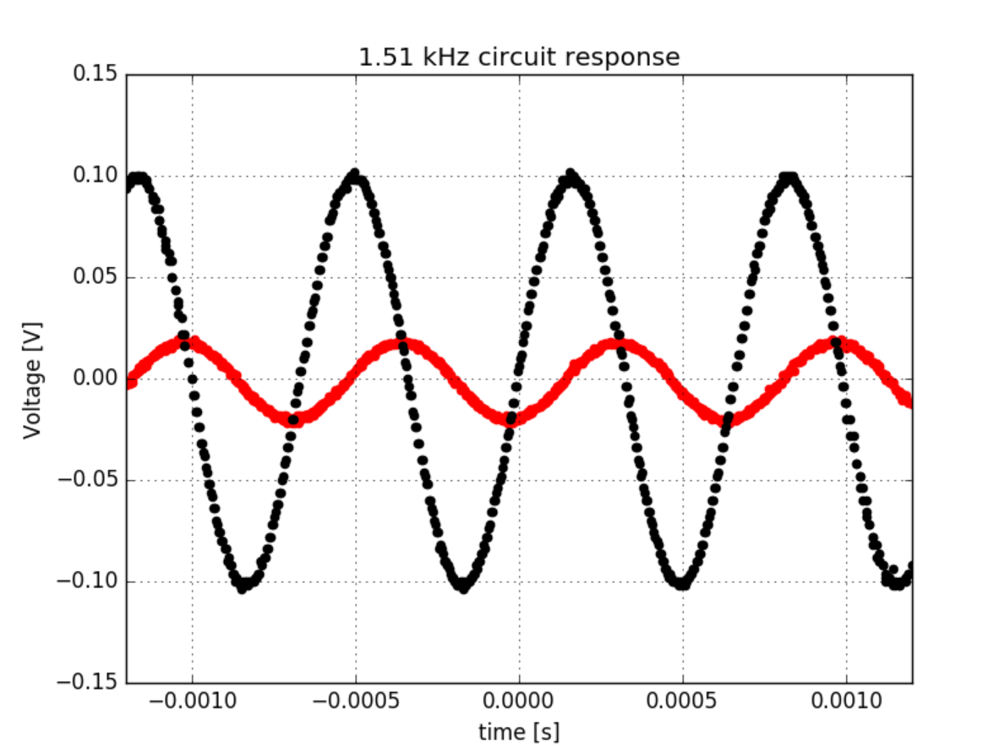

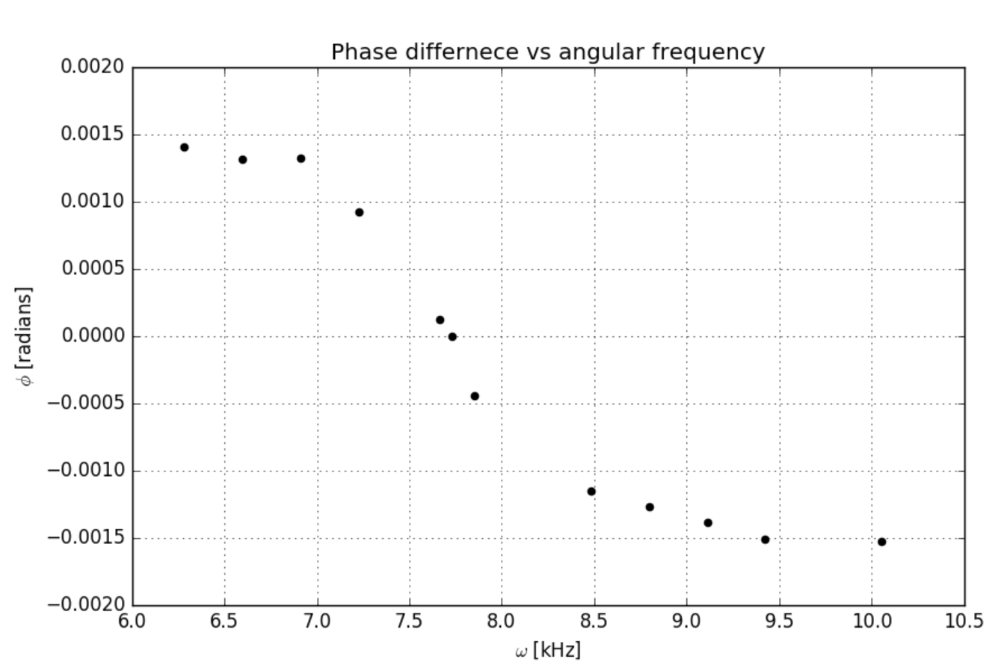

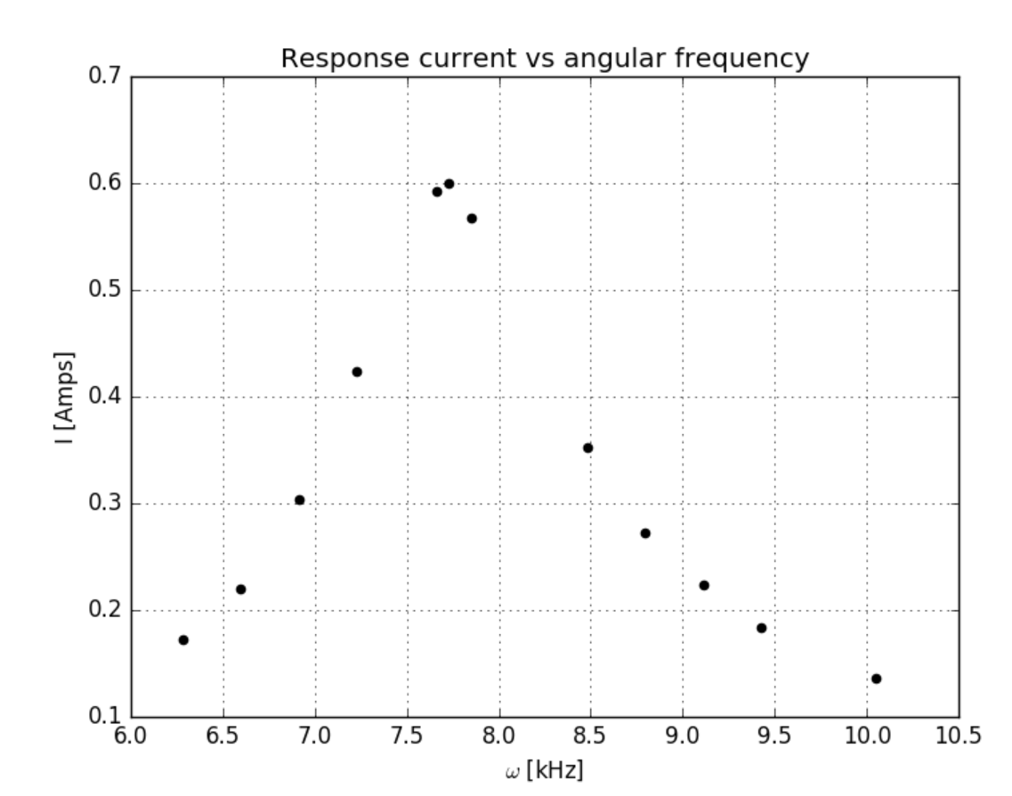

|  |  |  |  |  |
| --- | --- | --- | --- | --- |
| Case | Freq(kHz) | Lag time (us) | Vout (peak) | Vin (peak) |
| 1 | 1 | 224 | 17.2 | 100 |
| 2 | 1.05 | 200 | 22 | 98 |
| 3 | 1.1 | 192 | 30.4 | 98 |
| 4 | 1.15 | 128 | 42.4 | 90 |
| 5 | 1.22 | 16 | 59.3 | 70 |
| 6 | 1.23 | 0 | 60 | 70 |
| 7 | 1.25 | -56 | 56.8 | 74 |
| 8 | 1.35 | -136 | 35.2 | 94 |
| 9 | 1.4 | -144 | 27.2 | 90 |
| 10 | 1.45 | -152 | 22.4 | 96 |
| 11 | 1.5 | -160 | 18.4 | 98 |
| 12 | 1.6 | -152 | 13.6 | 98 |